Schema Parser Manual

Introduction
Schema parser is a engineer to parse the XML schema file.
It was implemented by javascript and defined in the file (schemaParse.js). In this file, it was not only defined the interface - "ISchemaParse", but also include a default implements - "NomralSchemaParse".

The simplicity of design is the main point about this interface. So, it just only has seven functions to finish the job.(See: Methods of the parse)

There are too many data types defined in w3c spec. In this parse, it just only implements some part of them, but it was very easy to add new type(it was called rule in parse).(See : How to define a new rule?)

Concepts of the parse
As the frameworks which parse XML schema file, there are three concepts be permeated from beginning to end.
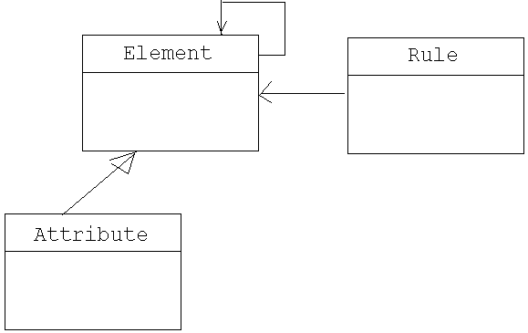
Element
In simplest terms, element looks like a node of tree and can be attached with many attributes or other elements on it.
Each element has a parent that parent is either the child of another element (like when an img is nested inside a p element).

Attribute
Attribute is element too! So, it can has all of the methods about element , but there is a difference between element and attribute that element can has it’s
Children but attribute not. Except it, you can consider them as a same concept.

Rule
Rule is a restriction to the element or attribute.
e.g,
User can delete or create a new element, even modify the values of the element’s attribute, but rule restrict this operations.

File structure
－ xmlextras.js
To create DOM object
－ variable.js
Define the global variables.
－ validate.js
The third party lib.
－ class.js
Define the classes such as Element, Attribute, Rule, RuleFactory and others which will be used in all js files.
－ schemaParse.js
The core code to parse the schema XML file.

－ s2hFunctions.js
－ schema2Html.js
Define a interface ISchema2Html and a default implement that convert XML into html form

Methods of the parse’s interface

Name | Parameters | Comments
Public methods:
findRootElement |  | To find the root element of the XML schema file
findElementByName | elementName | To search the element by the name.  If the element can not be funded, system will return a null object.  If the name is empty, it will return all elements which defined in the XML schema file.
findElementChildrens | elementName | To search the children of the element.  If the element is not existed, system will throw an exception.  Otherwise it will return an Array object (if element has no children , this object is empty)
findElementAttribute | elementName  attributeName | To find the attribute of the element, if the element is not existed, system will throw an exception.  Otherwise it will return the attribute or null(if the element has no attribute).
findElementAttributes | elementName | To find the attribute of element, if the element is not existed, system will throw an exception.  Otherwise it will return an array object(if the element has no attributes , this object is empty)
findElementRule | elementName | To find the rule of the element, if the element is not existed, system will throw an exception.  Otherwise it will return the rule or the default rule (if it is a special rule that can not be defined in the parse code).
findElementAttributeRule | elementName  attributeName | To find the rule of the attribute of the element.  if the element is not existed, system will throw an exception.  Otherwise, it will return the rule or the default rule (if it is a special rule that can not be defined in the parse code).
Private methods
_findSequenceNodeOfElement | _element | It is a helper method to find the element’s children.  In the w3c spec, if the element has children, the children node must be wrapped up by sequence node. Like  <xs:complexType>  <xs:sequence>  …………….  </xs:sequence  </xs:complexType
_findAttributeNodesOfElement | _element | It is a helper method to find the element’s attributes.

How to define a new rule?
Schema parse use the factory pattern to define new type.
In the w3c spec, there are too many types defined. It is easy to define a new type in the parse code. For example, if the “decimal” restriction of the attribute was not defined, you should follow these steps to add the new type.
In the class.js file
1> defined the new rule
/**
* The Rules class - BooleanRule
**/
function DecimalRule(_dvalue , _use){

this.name = "decimal";
this.defaultValue = _dvalue;
this.use = _use;

this.express = "";
this.validate = function(_value){
return _validate.isDecimal(_value);
}

}

2> add the logic code into RuleFactory class
if(base == "xs:decimal"){
return new DecimalRule(dvalue , use);
}

All Rules

Name | Type | restrict
DefaultRule
OccursRule | Element
StringRule | Attribute
BooleanRule | Attribute
DecimalRule | Attribute
NormalizedStringRule | Attribute
EnumNormalizedStringRule | Attribute
…..

How to use the parse?
To convert XML into html form, we defined an interface - ISchema2HtmlForm in schema2Html.js and Schema2HtmlForm is a default implement.
Certainly, you can define your own interface and implement it. The schema parse just only support a service interface to parse schema file, and it do not care of how to use it.

e.g Ischema2HtmlForm
Name | Parameters | Comments
initDomTree |  | Init a tree.  (It is difficulty to present the elements by use the DOM structure.  So, the best way is to define a new structure to represent it. ). optional
printContent |  | Represent all elements and it’s attributes.
printElement | _xelement | Represent one of the element.
printAttribute | _xelement | Represent one of the attribute of the element.
toXml |  | To convert the tree into a XML file.(If you use DOM structure to represent the content, you will find these method is very difficulty to implement).

Resources:
XML Schema Part 0: Structures, W3C, 2 May 2001
XML Schema Part 1: Structures, W3C, 2 May 2001
XMLchema Part 2: Datatypes, W3C, 2 May 2001
http://www-128.ibm.com/developerworks/cn/xml/x-schema/part1/
http://www-128.ibm.com/developerworks/cn/xml/x-schema/part2/
http://www-128.ibm.com/developerworks/cn/xml/x-schema/part3/

XML Schema 1.1 Part 1: Structures
XML Schema: Structures specifies the XML Schema definition language, which offers facilities for describing the structure and constraining the contents of XML documents, including those which exploit the XML Namespace facility. The schema language, which is itself represented in XML and uses namespaces, substantially reconstructs and considerably extends the capabilities found in XML document type definitions (DTDs).

